

CLOUD COMPUTING
LAB: 07
Submitted By:
Seerat Fatima
Registration. no:
2023-BSE-060
Submitted To:
Engr.Shoaib
Section:
5B

Task 1 — Print & filter environment variables

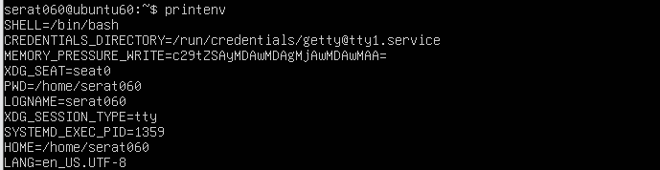
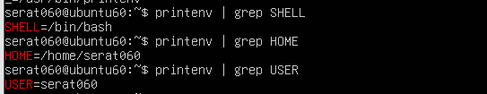

Task 2 — Export DB_* variables temporarily and observe scope

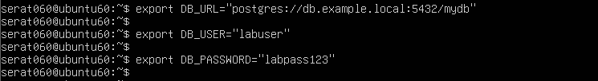
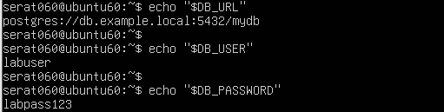
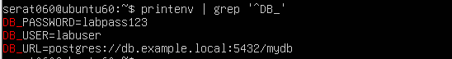
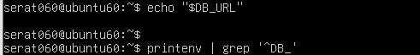
Task 3 — Make DB_* variables persistent in ~/.bashrc

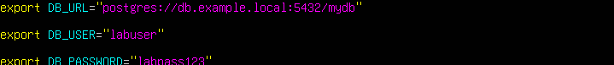
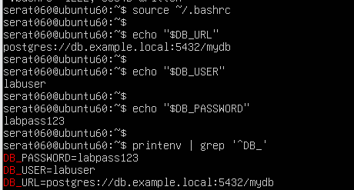
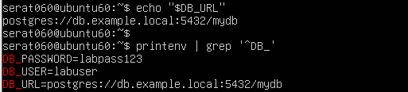

Task 4 — System-wide environment variable, welcome script, and PATH

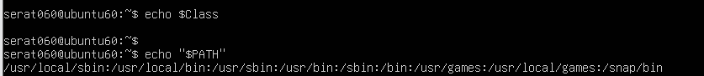
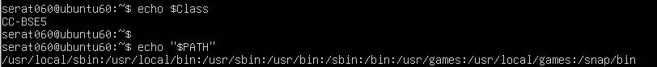
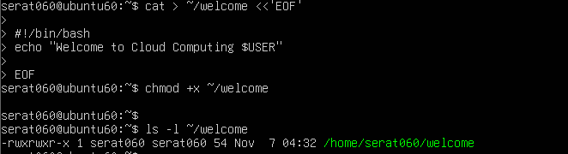
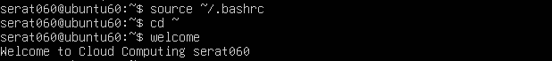

Task 5 — Block and allow SSH using ufw (firewall)

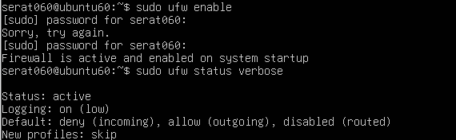
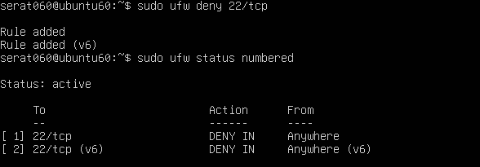
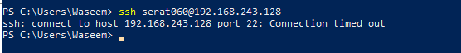
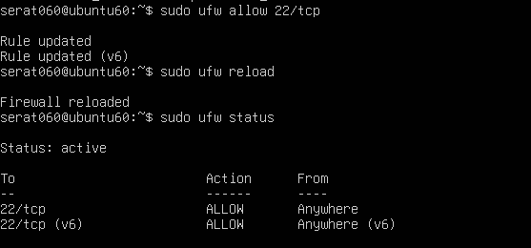
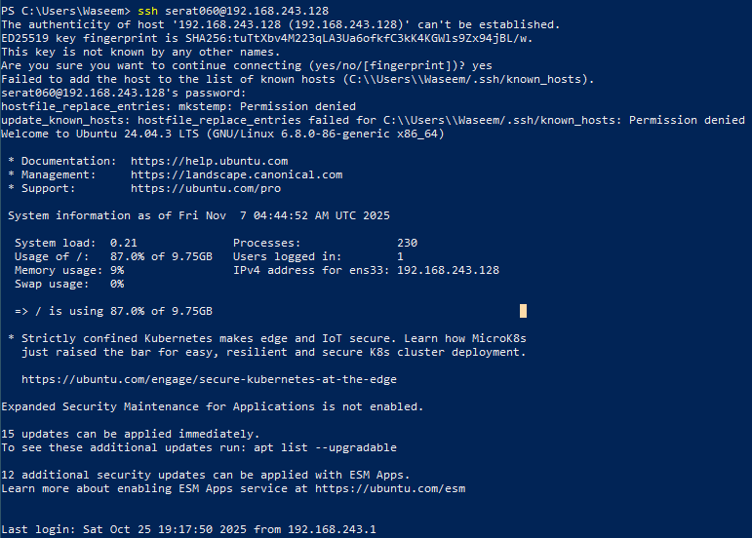

Task 6 — Configure SSH key-based login from Windows host

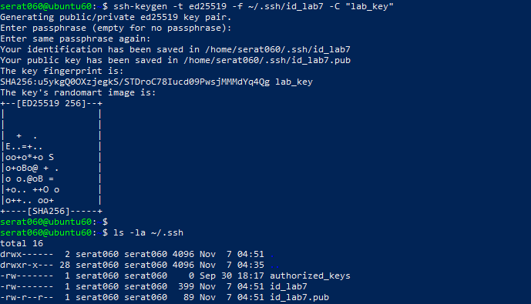
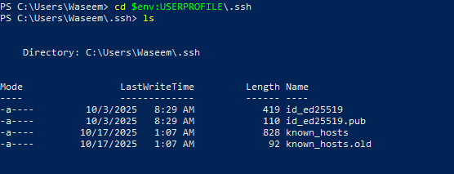
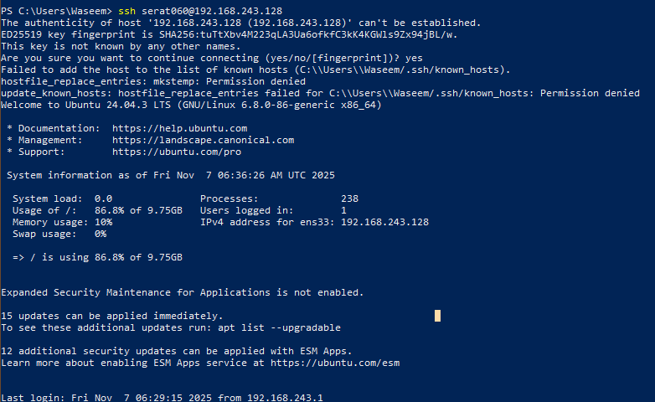
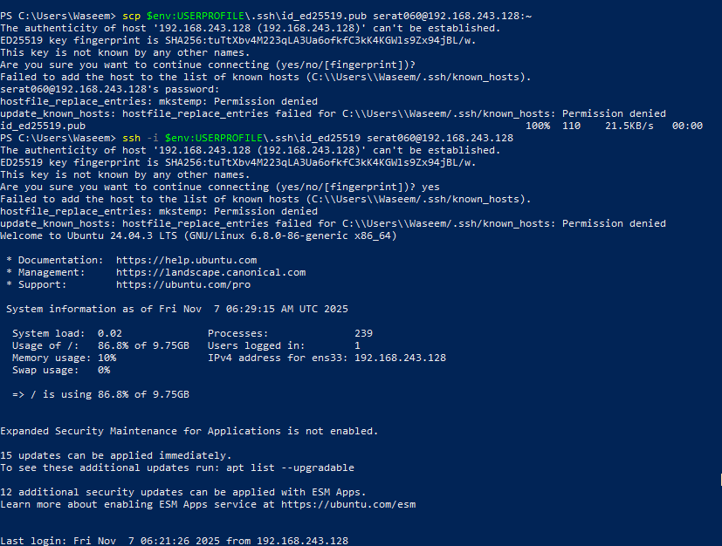

Exam Evaluation Questions
Q1: Quick Environment Audit

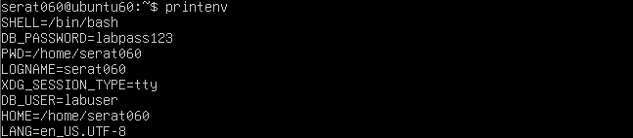
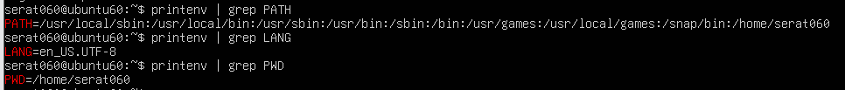

Q2: Short-lived Student Info

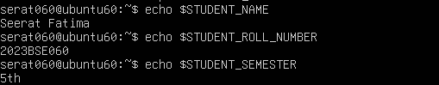
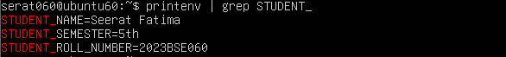
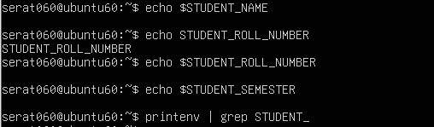

Q3: Make It Sticky (Persistence Check for Student Info)

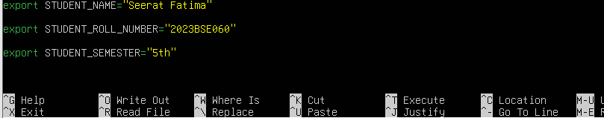
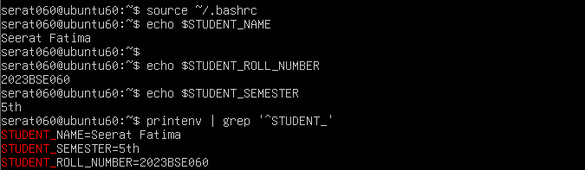
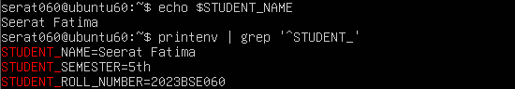
Q4: Firewall Rules: Block and Restore Ping (ICMP)

